Audience reports overview

Audience reports are located under “Audience” in the left-hand navigation. These reports can help you better understand the characteristics of your users. This can include what countries they’re in, what languages they speak, and the technology they use to access your site. But it can also include data like age and gender, their engagement and loyalty, and even some of their interests.

**Active Users report**

Let’s begin with the “Active Users” report. This can show you how many users had a least one session on your site in the last day, seven days, 14 days, and 30 days. We call this “site reach” or “stickiness.” If your marketing activities and site content encourage users to visit and return to your site, the active users in each time frame should grow.

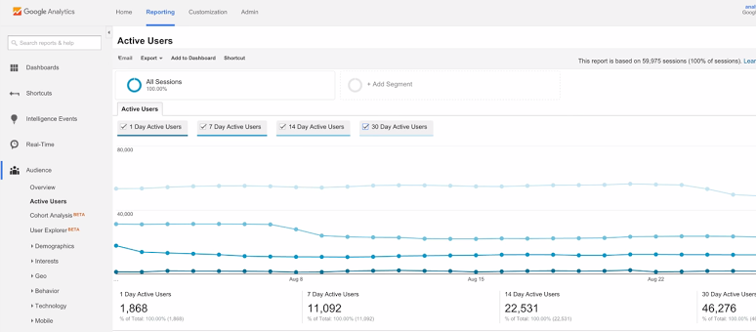

**Demographics and Interests reports**

Next, let’s look at the “Demographics” and “Interests” reports. The “Demographics” reports provide information about the age and gender of your users. The “Interests” reports show your users’ preferences for certain types of web content like technology, music, travel, or TV. This information is useful in two ways. First, if you know your target audience, it can help verify that you’re reaching the right people. Second, it can help guide decisions about your marketing and content strategy.

* Note that to see data in these reports, you must first enable advertising features in the “Demographics and Interests” reports for each property. Go into the “Admin” tab under “Property“ and select “Property Settings.” Under “Advertising Features,” set “Enable Demographics and Interest Reports” to on.

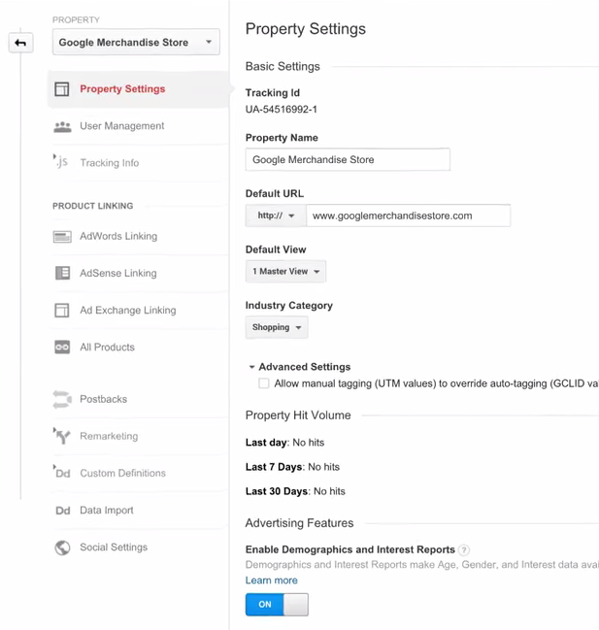

Once activated, you will see data in your Demographics and Interests reports about the age, gender, and interests of your users. Note that if you’ve just enabled this feature, it may take a day or two for data to appear in these reports. Also, the Demographic reports may not contain any data if your site traffic is very low or your segment is too small.

**Geographic reports**

The “Location” report under “Geo” is one of the most useful Audience reports. Google Analytics can anonymously determine a user’s continent, sub-continent, country, and city through the IP address used by their browser. Notice the geographic heat map at the top of the report, which you can adjust to display different metrics. For example, switching the map to show “percent of New Visits” lets you identify potential new markets based on new user traffic to your website. This can help you decide whether to build awareness or invest in customer loyalty in particular locations.

You could also use the table below the visualization to identify areas that have a high number of conversions (or transactions), but low traffic rates. That could indicate untapped markets to target with advertising.

Another analysis technique is to identify the regions where you already have a large audience, but lower than average performance. For example, if certain regions have a higher than average bounce rate (or users that leave after viewing a single page), you might need to optimize your advertising or website. Perhaps you need to translate your ad or site into the local language or add geographically-specific content.

**Behavior reports**

Below “Geo,” are a set of behavior reports that help you understand how often users visited and returned to your website. The “New vs Returning” report breaks out acquisition, behavior, and conversion goal metrics for new and returning users. You can look at this comparison over time to see how audience loyalty may be shifting. Consider your website objectives, as well as your marketing activities, when evaluating the mix of new and returning users to your site.

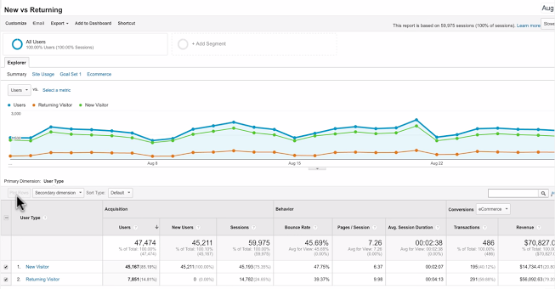

**Technology and Mobile reports**

Underneath Behavior reports, the “Technology” and “Mobile” reports can help you understand what technologies your audience uses to consume your site content. These reports can help you fine-tune your site to make sure it’s fully functional on different devices and browsers.

For example, you can use the “Browser and Operating systems” report to quickly identify issues with certain browsers on your site. If your site has a comparatively high bounce rate on a mobile browser, you may need to create a mobile-optimized version of your website with streamlined content and simpler navigation.

It’s also a good idea to understand if users are migrating from desktop to mobile and plan your development accordingly. You can use the “Overview” report under “Mobile” to see a breakdown of your traffic based on smartphones, tablets, and desktop devices. Check this report to see how quickly mobile usage of your site has grown over time.

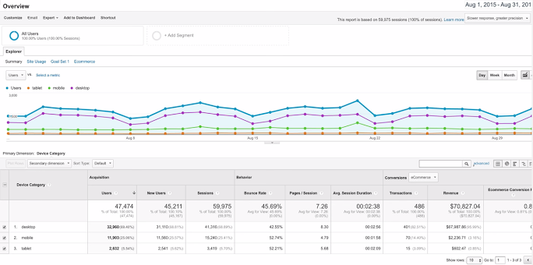

The “Devices” report lets you see additional details about the devices used to browse your site. This includes the mobile device name, brand, service provider, input selector, operating system, and other dimensions like screen resolution. These reports can give your developers and designers direction on how to create a mobile-optimized experience to best suit your users.